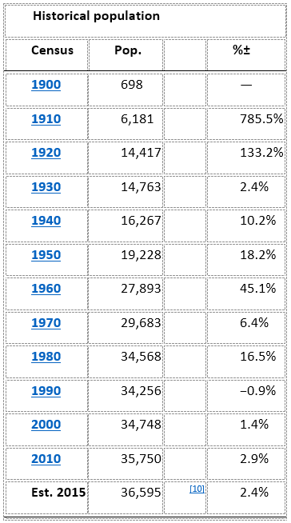
Bartlesville, Oklahoma

- Population: 36,595 as of 2015
- population density: 1,646.4 people per square mile
- 16,091 housing units at an average density of 762.4 per square mile
- Washington County population: 52,021 as of 2015
- Housing: 16,091 housing units at an average density of 762.4 per square mile
- Races: 82.09% White, 3.20% African American, 7.18% Native American, 0.96% Asian, 0.02% Pacific Islander, 1.02% from other races, and 5.54% from two or more races. Hispanic or Latino of any race were 3.02% of the population.
- Elevation: 705 ft.
- Area Total: 22.75 sq. mi (58.9 km2)
- Coordinates: 36°44′50″N 95°57′34″W

