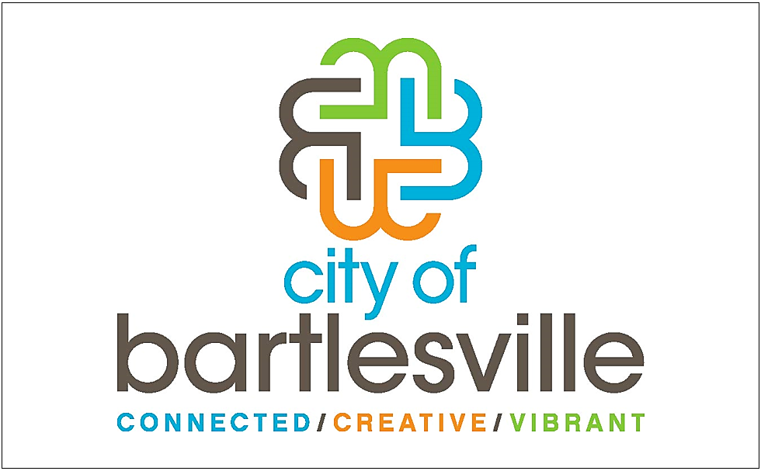

CityMaps of Bartlesville
CityMaps Phone App
link to website
Scan with QR code reader
QR readers are free from your phone’s app store
Note: many phone cameras have QR readers built-in

